Hardware
  - Your name
Computers perform a sequence of four functions called the information processing cycle. The four basic functions are inputting data, processing the data into information, displaying the information using output devices, and storing both information and data for subsequent use. Computer hardware, which includes the physical components of the computer, is involved in each of these four steps.
Hardware comes in different forms. Some is hidden in the system unit; other hardware is considered to be peripheral to the computer. Let's take a closer look at those components of the computer system that you manage daily: the system unit, the equipment that facilitates inputting data and commands, the equipment that emits audio and visual output, as well as the equipment that stores your work.

Table Of Content
- I-System Unit 3
A-Inside System Unit 3
1) Motherboard 4
2) CPU 4
3) MEMORY 6
Outside of the System Unit 7
1) Connectors and Ports 7
- Input Devices 10
Keyboard 10
The Mouse 11
Speech Recognition & Microphones 11
Scanners 12
- Output Devices 13
Monitors 13
Printers 14
Additional Output Devices 15
- Storage Devices 16
Memory Versus Storage 16
Hard Disk 17
1) Factors Affecting Hard Disk Performance 19
Network Attached Storage (NAS) 19
Flash Drives and Storage 20
Optical Storage Devices 21
1) Protecting the Data on Your Discs: 21

Table of Figures

Figure 1: System Unit 3
Figure 2: inside system unit-general view 4
Figure 3: devices inside system units 6
Figure 4: System unit from backside 8
Figure 5: keyboard 11
Figure 6:plotter 16
Figure 7:storage devices 17

I-System Unit
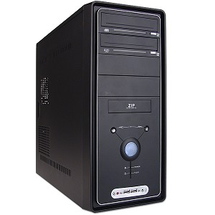
The system unit is a boxlike case that houses the computer's main hardware components. The system unit is actually more than just a case: It provides a sturdy frame for mounting internal components, including storage devices, a power supply, a fan, and connectors for input and output devices; it protects those components from physical damage; and it keeps them cool. A good case also provides room for system upgrades, such as additional disk drives.
Figure 1: System Unit

System units come in a variety of styles. In some desktop computing systems, the system unit is a separate metal or plastic box. Originally these cases were horizontal and were positioned on top of a desk, often with a monitor sitting on top—thus the name "desktop." To minimize the space it occupied, the case needed a small footprint, which was the amount of space used by the device. The tower case, a system unit case designed to sit on the floor next to a desk, provided the solution. The tower case has a vertical configuration, being tall and deep. A smaller version is called a minitower case. In a notebook computer or a personal digital assistant (PDA), the system unit contains all the computer's components, including input components, such as a keyboard, and output components, such as the display. Some desktop computers, such as Apple's iMac, contain the display within the system unit, making them all-in-one systems.

A-Inside System Unit
Most computer users don't need to open their system units; they receive their computers in ready-to-use packages. However, if you ever need to open your system unit, remember that the computer's components are sensitive to static electricity. If you touch certain components while
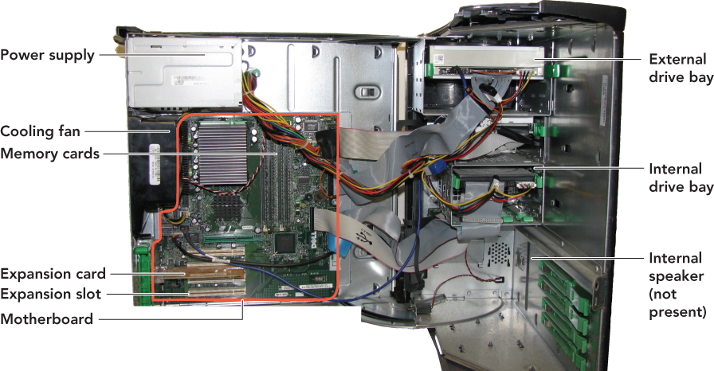
you're charged with static electricity, you could destroy them. To avoid this disaster, always disconnect the power cord before opening your computer's case, and discharge your personal static electricity by touching something that's well-grounded or by wearing a grounding bracelet. If you open your system unit, you'll see the following components:
Figure 2: inside system unit-general view

Motherboard
The motherboard acts as the backbone of the system unit to which all devices are connected. The motherboard is a large flat piece of plastic or fiberglass that contains thousands of electrical circuits etched onto the board's surface. The circuits connect numerous plug-in receptacles, which accommodate the computer's most important components (such as the CPU). The motherboard provides the centralized physical and electrical connectivity to enable communication among these critical components. Let's look at some of the most important components you'll see on the motherboard: the CPU (or microprocessor), the system clock, the chipset, input/output buses, and memory.

CPU
The central processing unit (CPU) is a microprocessor (or processor for short)—an integrated circuit chip that is capable of processing electronic signals. It interprets and carries out software instructions by processing data and controlling the rest of the computer's components. Processors are embedded in all kinds of electronic and mechanical devices such as smart-phones, calculators, automobile engines, as well as industrial and medical equipment. They process data so humans can enjoy the information put out by their effective and efficient operation. No single element of a computer determines its overall performance as much as the CPU.
A CPU contains two subcomponents: the control unit and the arithmetic logic unit. The control unit extracts instructions from memory and then decodes and executes them. Under the direction of a program, the control unit manages four basic operations:
• Fetch: Retrieves the next program instruction from the computer's memory.
• Decode: Determines what the program is telling the computer to do.
• Execute: Performs the requested instruction, such as adding two numbers or deciding which one of them is larger.
• Store: Stores the results in an internal register or in RAM.
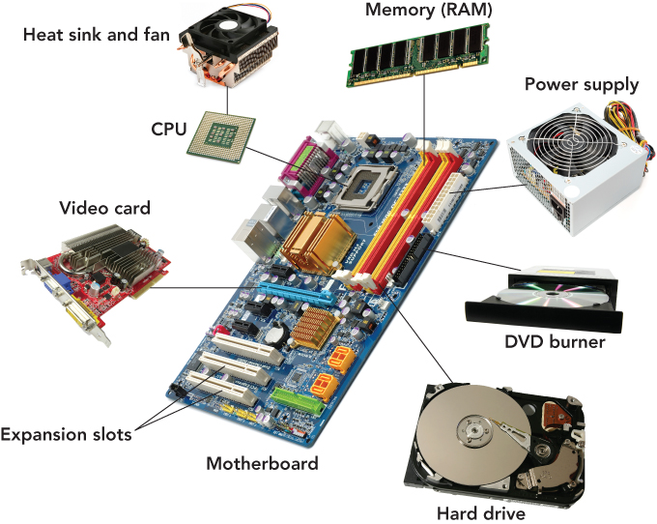
This four-step process is called a machine cycle, or processing cycle, and consists of two phases: the instruction cycle (fetch and decode) and the execution cycle (execute and store). Today's micro-processors can go through this entire four-step process billions of times per second. The arithmetic logic unit (ALU), as its name implies, can perform arithmetic or logical operations
Figure 3: devices inside system units

3) MEMORY
Memory refers to the chips that enable the computer to retain information. Memory chips store program instructions and data so the CPU can access them quickly. As you'll see in this section, the computer's motherboard contains several different types of memory, each optimized for its intended use.

RAM
The large, rectangular memory modules housed on the computer's motherboard contain the computer's random access memory (RAM). RAM stores information temporarily so it's directly and speedily available to the microprocessor. This information includes all work in progress— program instructions as well as the data to be processed by the program. RAM is volatile memory, which means it is not permanent and its contents are erased when the computer's power is switched off. Why is it called random access memory? RAM is called random access because any storage location can be accessed directly without having to go from the first location to the last in sequential order.
How much RAM does a computer need? In general, the more memory the better. Windows Vista and Mac OS X theoretically require only 512 MB of RAM, but neither system functions well with so little. For today's Microsoft Windows, Linux, and Macintosh operating systems, 1 GB of RAM is a practical working minimum.

Virtual memory
Frequently operating systems use virtual memory in addition to RAM. With virtual memory, the computer looks at RAM to identify data that have not been used recently and copies those data onto the hard disk. This frees up space in RAM to load a new application or increase the space needed by a program currently in use. The computer uses virtual memory when RAM gets full (which can easily happen if you run two or more programs at once). Accessing data on a disk drive is much slower than using RAM, so when virtual memory kicks in, the computer may seem to slow to a crawl.

ROM
If everything in RAM is erased when the power is turned off, how does the computer start up again? The answer is read-only memory (ROM), a type of memory in which instructions have been prerecorded. The instructions to start the computer are stored in read-only memory chips located on the motherboard. When a computer is turned on, the instructions in ROM are read; they cannot be erased. In contrast with RAM, ROM is nonvolatile memory, meaning it retains information even when the power is switched off.

CACHE MEMORY
Cache memory is a small unit of ultrafast memory built into the processor that stores frequently or recently accessed program instructions and data. Cache (pronounced "cash") memory is much faster than RAM, but it's also more expensive. Although relatively small compared with RAM, cache memory greatly improves the computer system's overall performance.
The following sections explore what can be found on the outside of the system unit of a typical desktop computer.

Outside of the System Unit

Connectors and Ports
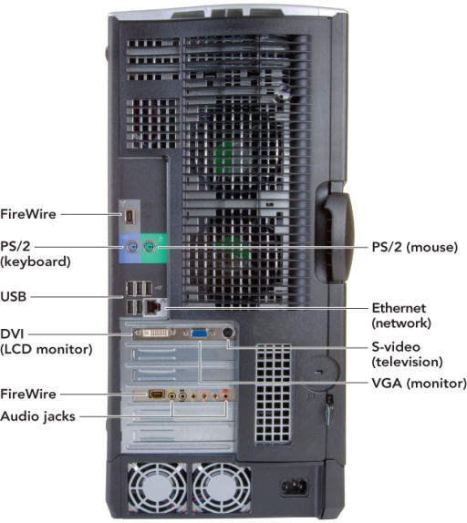
A connector is a physical receptacle located on the system unit or an expansion card that is visible on the outside of the unit.
Figure 4: System unit from backside
Expansion cards are plug-in adapters that fit into slots on the motherboard and connect the computer with various peripherals. The connectors on these cards are located on extender pieces that are visible through slots on the outside of the system case, enabling you to connect peripheral devices such as a printer, keyboard, or mouse.

USB 2.0
USB 2.0 ports use an external bus standard that supports data transfer rates of 480 Mbps (480 million bits per second) between the computer and its peripheral devices; they do not transfer data between devices within the system. Some advantages include hot swapping and support for plug-and-play (PnP). Hot swapping is the ability to connect and disconnect devices without shutting down your computer. This is convenient when you're using portable devices that you want to disconnect often, such as a digital camera. PnP refers to a set of standards, jointly developed by Intel Corporation and Microsoft, that enable a computer to automatically detect the brand, model, and characteristics of a device when you plug it in and configure the system accordingly.
Up next on the horizon is USB 3.0, known as SuperSpeed USB. USB 3.0 is expected to use a fiber optic link to attain a data transfer rate of 4.8 Gbps—up to 10 times faster than USB 2.0. Additionally, USB 3.0 will be compatible with older versions, providing the same benefits while consuming less power.

1394 PORTS (FIREWIRE)
In 1995 Apple introduced FireWire, an interface Apple created and standardized as the IEEE 1394 High Performance Serial Bus specification. It is also known as Sony i.Link or IEEE 1394, the official name for the standard. FireWire is similar to USB in that it offers a high-speed connection for dozens of peripheral devices (up to 63 of them). It is especially well suited for transmitting digital video and audio data.
On non-Apple systems a FireWire port is called a 1394 port after the international standard that defines it. Like USB, FireWire enables hot swapping and PnP. However, it is more expensive than USB and is used only for certain high-speed peripherals, such as digital video cameras, that need greater throughput (data transfer capacity) than USB provides.
You may find the following additional ports and connectors on the exterior of a computer's case or on one of the computer's expansion cards:

Telephone connector
The typical modem interface, a telephone connector (called RJ-11), is a standard modular telephone jack that will work with an ordinary telephone cord.

Network connector
Provided with networking adapters, the network connector (called an RJ-45 or Ethernet port) looks like a standard telephone jack but is bigger and capable of much faster data transfer.

Game card connector
Game cards provide connectors for high-speed access to the CPU and RAM for graphics-intensive interaction.

TV/sound capture board connectors
If your computer is equipped with TV and video capabilities, you'll see additional connectors that look like those found on a television monitor. These include a connector for a coaxial cable, which can be connected to a video camera or cable TV system.

Input Devices
Input refers to providing data and instructions into the computer for processing. This section discusses input devices, the hardware components that make it possible for you to get data and instructions into RAM, where it is held while in use.

Keyboard
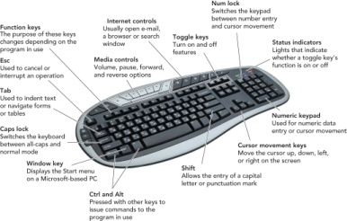
Despite all of the high-tech input devices on the market, the keyboard is still the most common. A keyboard is an input device that uses switches and circuits to translate keystrokes into a signal a computer understands.
Figure 5: keyboard

The Mouse
A pointing device is an input device that allows you to control the movements of the on-screen pointer. The most widely used pointing device is the mouse. Although older roller-ball mice needed a mouse pad for traction, newer optical mice do not unless the surface that supports them is reflective or the wrong texture. Another type of mouse, the wireless mouse (also called a cordless mouse), transmits infrared or radio signals (RF) to a base station receiver on the computer. Wireless mice eliminate the cord tangling associated with the corded variety. The infrared mouse requires line of sight to the receiver, whereas the RF variety uses radio waves that transmit in a wider pattern, eliminating the line of site requirement.

Speech Recognition & Microphones
Speech recognition, also called voice recognition, is the conversion of spoken words into computer text. The spoken word is first digitized and then matched against a dictionary of coded voice waves. The matches are converted into text as if the words were typed on the keyboard. This method of input is favored by individuals for whom traditional input devices are not an option (for example, those with limited hand movement) and by those who want to significantly limit their use of the mouse and keyboard while maintaining or increasing their overall productivity (for example, writers). To accept speech, a computer must have a microphone, an input device that converts sound waves into electrical signals that the computer is able to process.
A speech recognition system that works with Microsoft's mainstream applications is included in the Microsoft Vista and Windows 7 operating systems. It is a speaker-independent continuous system that allows the user to dictate documents and e-mails, use voice commands to start and switch between applications, control the operating system, and even fill out forms on the Web.

Scanners
A scanner copies anything that's printed on a sheet of paper, including artwork, handwriting, and typed or printed text, and converts the input into a graphics image for the computer. The scanner does not recognize or differentiate the type of material it is scanning. Everything is converted into a graphic bitmapped image, a representation of an image as a matrix of dots called picture elements (pixels). All images acquired by digital cameras and camcorders, scanners, and screen capture programs are bitmapped images. Most scanners use optical character recognition (OCR) software to automatically convert scanned text into a text file instead of a bit mapped image. Even though this technology has greatly improved, foreign characters and poor quality of the original document will increase the errors in the final file.

Output Devices
Output devices enable people to see, hear, and even feel the results of processing operations. The most widely used output devices are monitors and printers.

Monitors
Monitors (also called displays) are screens that display data and processed information called output. It's important to remember that the screen display isn't a permanent record. To drive home this point, screen output is sometimes called soft copy, as opposed to hard copy (printed output). To make permanent copies of your work, you should save it to a storage device or print it.
There are two basic types of monitors. The big, bulky cathode-ray tube (CRT) monitors that look like traditional televisions and are usually connected to older desktop computers and the thin, popular liquid crystal display (LCD) monitors like those that accompany new desktops and all-in-one units, and are incorporated into notebooks, handheld computers, and smart-phones.
Liquid crystal displays (LCDs), or flat-panel displays, are rapidly replacing CRT monitors. An LCD screen is also a grid of pixels. A florescent panel at the back of the system generates light waves to make the images and colors. These waves pass through a layer of crystal solution. The electric current moves the crystals and either blocks the light or lets it through, thus creating the images and colors viewable on the display. The least expensive LCDs are called passive-matrix LCDs (also called dual scans). In these units, the electrical current drives the display by charging groups of pixels, either in a row or column, at once. The screen brightens and fades as the current moves from group to group. Appliances, toys, remote controls, and home medical products use this type of display. Passive-matrix LCD displays are usually not as sharp as active-matrix displays, have less of a viewing angle, and are too slow for full-motion video. Active-matrix, or Thin Film Transistor (TFT), technology drives the display by charging each pixel individually as needed.
Screen Size The size of a monitor is determined by measuring it diagonally. Typical desktop PC monitors range from 17 to 21 inches, whereas notebook computers measure 12 to 17 inches. In fact, a recent study commissioned by Apple looked at the productivity impact of using a 30-inch monitor as compared to a 20-inch or 17-inch monitor. The results indicated that a user on a 30-inch monitor would save about 1.3 hours per week over a person using a 17-inch monitor. The report is based on what they consider to be normal usage. Depending on your work, the savings in productivity could be much greater.
The term resolution generally refers to the sharpness of an image and is controlled by the number of pixels on the screen. The higher the resolution, the sharper the image is. Units of resolution are written as 1024 X 786. This notation means the display has 1,024 distinct dots on each of 768 lines.

Printers
Printers produce a permanent version, or hard copy, of the output on the computer's display screen. Some of the most popular printers are inkjet printers and laser printers.
Inkjet printers are relatively inexpensive nonimpact printers that produce excellent color output, making them popular choices for home users. They spray ionized ink from a series of small jets onto a sheet of paper, creating the desired character shapes. Today, inkjet printers are capable of producing high-quality print approaching that produced by laser printers. A typical inkjet printer provides a resolution of 300 dots per inch, although some newer models offer higher resolutions. One drawback of an inkjet printer is that it is relatively slow compared with its laser competitor.
A laser printer is a high-resolution nonimpact printer that uses an electrostatic reproductive technology similar to that used by copiers. Under the printer's computerized control, a laser beam creates electrical charges on a rotating print drum. These charges attract toner, which is transferred to the paper and fused to its surface by a heat process. Laser printers print faster than inkjets; some laser printers can crank out 60 or more pages per minute. Black and white laser printers are becoming more affordable and generally have a lower per-page print

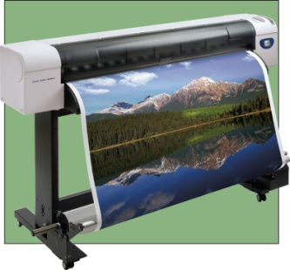
cost than inkjet printers; however, color laser printers are still more expensive to buy and maintain.
Figure 6:plotter

A plotter is a printer that produces high-quality images by physically moving ink pens over the surface of the paper. A continuous-curve plotter draws maps from stored data.

Additional Output Devices
All systems include basic built-in speakers to transmit the beeps normally made during processing. These speakers, however, are not designed for playing CDs. You'll have to purchase speakers to listen to computer-generated sound, such as music and synthesized speech, unless higher-end speakers were included with your system. Like microphones, speakers require a sound card to function. Sound cards play the contents of digitized recordings, such as "music recorded in WAV (short for waveform) and MP3 sound file formats. Some sound cards do this job better than others. Quality is most noticeably a consideration when the sound card reproduces MIDI (musical instrument digital interface) files.
Computers equipped with a fax modem and fax software can receive incoming faxes. The incoming document is displayed on the screen, and it can be printed or saved. Computers also send faxes as output. To send a fax using your computer, you must save your document using a special format that is compatible with the fax program. The fax program then sends the document through the telephone system to a traditional distant fax machine. This output function is helpful because you don't have to print the document to send it as a fax.
Multifunction devices combine inkjet or laser printers with a scanner, a fax machine, and a copier, enabling home office users to obtain all of these devices without spending a great deal of money.
Now that you've learned about a variety of output devices, let's look at how you can store data for later use.

Storage Devices
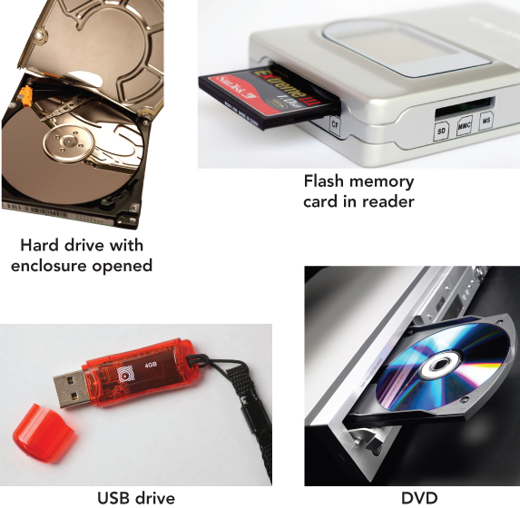
Storage (also called mass storage, auxiliary storage, or secondary storage) refers to the ways a computer system retains software and data for future use. Storage relies on two components— recording media and storage devices. Recording media are hardware compo-nents, such as hard disks, floppy disks, flash memory, CDs, and DVDs, on which data is held. The storage device is the computer hardware that facilitates embedding data onto recording media. In other words, storage devices are the actual-drives (hard drive, floppy drive, USB flash drive, and so on) that contain the tools to place the data on the recording media.
Figure 7:storage devices

Memory Versus Storage
To understand the distinction between memory and storage, think of the last time you worked at your desk. In your file drawer you store all your personal items and papers, such as your checking account statements. The file drawer is good for long-term storage. When you decide to work on one or more of these items, you take it out of storage and put it on your desk. The desktop is a good place to keep the items you're working with (work in progress); they're close at hand and available for use right away. Your desktop can be thought of as memory—the place where you temporarily put things that you are using or working on.
Computers work the same way. When you want to work with the contents of a file, the computer transfers the file to a temporary workplace: the computer's memory— technically called RAM (random access memory) or primary memory. This memory is a form of storage—a holding area for items in use—but it is temporary. Why don't computers just use RAM to hold all of a user's files, regardless of whether or not they are in use? Here are some reasons:
Recording media retain data when the current is switched off. The computer's RAM is volatile. This means that when you switch off the computer's power, all of the information in RAM is irretrievably lost. So, if your work in progress has not been saved onto a recording medium by a storage device, it is no longer retrievable unless the application you were running has an auto save feature for emergency rescue. In contrast, recording media are nonvolatile; they will not lose data when the power goes off or when they are removed from the system.
Storage devices are cheaper than memory. RAM operates very quickly to keep up with the computer's CPU. For this reason, RAM is expensive— much more expensive than storage. In fact, most computers are equipped with just enough RAM to accommodate all of the programs a user wants to run at once. In contrast, a computer system's storage devices hold much more data and software than the computer's memory does.
Storage devices play an essential role in system start-up operations. When you start your computer, the operating system appears on the monitor. Actually, a copy of the operating system software is transferred from the hard disk, where it is permanently stored, into the computer's RAM—making it available and ready for use.
Storage devices are needed for output. When you've finished working, you use the computer's storage system as an output device to save a file. When you save a file, the computer transfers your work from the computer's RAM to recording media via a storage device. If you forget to save your work, it will be lost when you switch off the computer's power. Remember, the computer's RAM is volatile!

Hard Disk
On almost all computers, the hard disk drive is by far the most important storage device. A hard disk drive (or simply hard disk) is a high-capacity, high-speed storage device, usually housed in the system unit, that consists of several rapidly rotating disks called platters on which programs, data, and processed results are stored. To communicate with the CPU, hard disks require a hard disk controller.
The computer's hard disk, also referred to as secondary, or fixed, storage, consists of the storage devices that are actively available to the computer system and that do not require any action on the part of the user. Hard disks can also be categorized as both random access and magnetic storage devices. A random access storage device can go directly to the requested data without having to go through a linear search sequence. Magnetic storage devices use disks that are coated with magnetically sensitive material. Magnetic storage devices use an electromagnet called a read/write head that moves across the surface of a disk and records information by transforming electrical impulses into a varying magnetic field. As the magnetic materials pass beneath the read/write head, this varying field forces the particles to be rearranged in a meaningful pattern of positive and negative magnetic indicators that represents the data. This operation is called writing. When reading, the read/write head senses the recorded pattern and transforms this pattern into electrical impulses that are decoded into text characters. A hard disk contains two or more vertically stacked platters, each with two read/write heads (one for each side of the disk). The platters spin so rapidly that the read/write head floats on a thin cushion of air, at a distance l/300th the width of a human hair. To protect the platter's surface, hard disks are enclosed in a sealed container.
How does the read/write head know where to look for data in order to access it randomly? To answer this question, you need to know a little about how stored data is organized on a disk. Like a vinyl record, disks are formatted, physically laid out, in circular bands called tracks. Each track is divided into pie-shaped wedges called sectors. Two or more sectors combine to form a cluster.
To keep track of where specific files are located, the computer's operating system records a table of information on the disk. This table contains the name of each file and the file's exact location on the disk. Older versions of Microsoft Windows called this the file allocation table, or FAT. The current system for Windows NT, 2000, XP, Vista, and Windows 7 is known as NTFS (new technology file system) and is more advanced and powerful. It improves performance and is required to implement numerous security and administrative features in the operating system. Hard disks can be divided into partitions. A partition is a section of a hard disk set aside as if it were a physically separate disk. Partitions are required if a system is going to give the user an option of running more than one operating system. The average user won't need to partition the hard disk, but some individuals like to create one partition for Linux and another for Microsoft Windows. In this way, they work with programs developed for either operating system.

Factors Affecting Hard Disk Performance
If a hard disk develops a defect or a read/write head encounters an obstacle, such as a dust or smoke particle, the head bounces on the disk surface, preventing the computer from reading or writing data to one or more sectors of the disk. Hard disks absorb minor jostling without suffering damage, but a major jolt—such as one caused by dropping the computer while the drive is running—could cause a head crash to occur. Head crashes are one of the causes of bad sectors, areas of the disk that have become damaged and can no longer reliably hold data. If you see an on-screen message indicating that a disk has a bad sector, try to copy the data off the disk and don't use it to store new data.
A hard drive's most important performance characteristic is the speed at which it retrieves desired data. The amount of time it takes a device from the request for the information to the delivery of that information is its access time. Access time includes the seek time, the time it takes the read/write head to locate the data before reading begins. Positioning performance refers to the time that elapses from the initiation of drive activity until the hard disk has positioned the read/write head so that it can begin transferring data. Transfer performance refers to how quickly the read/write head transfers data from the disk to random access memory. One way disk manufacturers improve transfer performance is to in-crease the speed at which the disk spins, which makes data available more quickly to the read/write heads. Another way is to improve the spacing of data on the disk so that the heads can retrieve several blocks of data on each revolution.

Network Attached Storage (NAS)
As demands for data storage have increased, network attached storage (NAS) devices are becoming more popular. NAS devices are comprised primarily of hard drives or other media used for data storage and are attached directly to a network. The network connection permits each computer on the network to access the NAS to save or retrieve data.
Remote storage, sometimes referred to as an Internet hard drive, is storage space on a server that is accessible from the Internet. In most cases, a computer user subscribes to the storage service and agrees to rent a block of storage space for a specific period of time. Instead of sending e-mail attachments to share with family and friends, you might simply post the files to the remote storage site and then allow them to be viewed or retrieved by others. You might save backup copies of critical files or all the data on your hard disk to your Internet hard drive.
The key advantage of this type of remote storage is the ability to access data from multiple locations. You can access your files from any device that connects with the Internet, so everything you store on the site is available to you at any time. Some disadvantages are that your data may not be secure; the storage device might become corrupt, causing you to lose your data; and the company offering the Internet storage may go out of business.

Flash Drives and Storage
Although hard disks are currently the most important storage media, the disks explored in this section are examples of portable storage, which means that you can remove a disk from one computer and insert it into another. A flash drive is a type of storage device that uses solid-state circuitry and has no moving parts. Flash drives are also known as solid-state drives (SSDs) and use flash memory, which is nonvolatile, electronic memory. Flash memory stores data electronically on a chip in sections known as blocks. Rather than erasing data byte by byte, flash memory uses an electrical charge to delete all of the data on the chip or just the data contained in a specific block, which is a much quicker method than other types of storage use. Flash memory is limited to 100,000 write cycles. This means information can be written and erased 100,000 times to each block, which could conceivably take years to occur. Because of their lack of moving parts, lower power consumption, and lighter weight, flash drives are becoming an alternative to hard disk drives, especially in notebook computing. Flash drives are also found in some MP3 players, smartphones, and digital cameras. Although flash drives are more expensive and have less storage capacity than hard disk drives, these differences are expected to erode over time. Additionally, some hard disk drives are incorporating flash technology, creating hybrid hard drives (HHDs) that use flash memory to speed up the boot process.
Another form of flash storage is the USB flash drive. USB flash drives, also known as memory sticks, thumb drives, or jump drives, are popular portable, or removable, storage devices. Because of their small size and universal ease of use, they have supplanted floppy disks and Zip disks as the removable storage medium of choice.

Optical Storage Devices
Software, music, and movies used to be distributed primarily on CDs and DVDs, however today direct downloads from the Internet have caused some manufacturers to make these drives an optional component of the system unit. If a unit does not come with a CD or DVD drive, you can purchase an external unit and connect it via the USB port. CD-ROM (short for compact disc read-only memory) and DVD-ROM (digital video [or versatile] disc read-only memory) are the most popular and least expensive types of optical disc standards and are referred to as optical storage devices. These discs are read-only discs, which means that the data recorded on them can be read many times, but it cannot be changed or erased. Notice that when the storage medium is optical, the correct spelling is disc. Magnetic storage media are spelled with a k—disk.

Protecting the Data on Your Discs:
As with magnetic disks, it's important that you handle CDs and DVDs carefully. The following are a few things to remember when caring for discs:
• Do not expose discs to excessive heat or sunlight.
• Do not touch the underside of discs. Hold them by their edges.
• Do not write on the label side of discs with a hard instrument, such as a ballpoint pen.
• To avoid scratches, do not stack discs.
• Store discs in jewel boxes (plastic protective cases) or paper-like sleeves when not being used.

This document is taken from the textbook “computers are your future”

